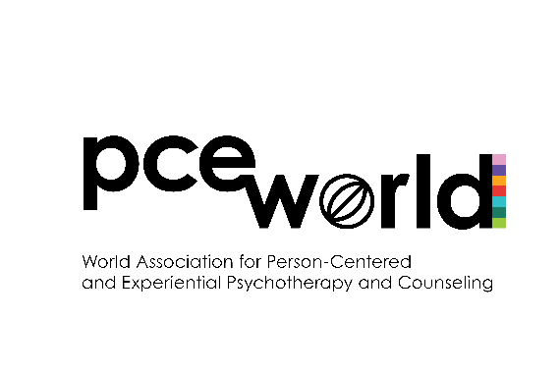
PCE World General
Research Grant Application

- Purpose and aims
  - PCE World General Research Grant is a form of financial assistance provided by the World Association to any researcher whose research projects are aimed at the investigation of the Person-Centered and Experiential (PCE) approach.
  - The main purpose of the Grant is to stimulate worldwide research activities related to the PCE field.
- Eligibility
  - Applicants must be individual members of PCE World with an active membership status for the current year.
  - Applicants must not be a PCE World Board member, PCE World Scientific Committee member, PCE World chapter Chair or Board member, or PCEP Editor.
  - Applicants cannot simultaneously apply for PCE World General Grant and PCE World Student Grant.
  - Recipients of PCE World Student Grant are not eligible for PCE World General Grant up until the end of work sponsored by the Student Grant. An ongoing project that was already sponsored by PCE World Student Grant may not be submitted for the PCE World General Grant.
  - There are no restrictions on applicants’ gender, age, nationality, PCE ‘tribe’ or any other basis except for those listed in 2.1-2.4 above.
- Application and selection procedure
  - The PCE World Board will announce a Call for applications at least 2 months before the deadline.
  - Applicants will complete and electronically submit all required forms (see #4 below) to the Grants Committee.
  - The Grants Committee (in consultation with the PCE World Board) will evaluate the applications based on the following evaluation criteria:
    - Significance of the research topic:
      - Clear topic context, main aim of the study, with theoretical and practical significance to the PCE field.
    - Quality of the proposed methodology:
      - Clarity of the conceptual/theoretical framework, research design, and overall methodology.
    - Feasibility of the study:
      - Feasible in scope.
      - If part of a larger project, specifies a clear output relating to the Grant.
  - The full Grants Committee will vote on the submitted applications. Depending on the number and quality of the applications (assessed using the above criteria), a decision may be taken to offer partial Grants (e.g., 1/2; 1/3 of the allocated amount) or not to offer any Grant. The latter decision should be approved by the PCE World Board.
  - After the Grants Committee selects an application, the PCE World Board will be informed. The PCE World Board will then make a formal announcement and arrange for the transfer of money.
  - Successful applicant(s) will receive the full amount they were Granted in one payment.
- Submission forms: All materials should be submitted together.
  - Cover Page: (see below)
  - Narrative Proposal: A 4-5 page summary proposal (1,200 – 1,500 words) that includes the research topic, main aim of the study, short literature review, proposed methodology, hypothesis/research question, and potential impact on the PCE field. The proposal must be written specifically for this grant. While you may draw on existing proposals, submitting an unchanged prior proposal is not appropriate. **If you plan to use the Grant money for a part of a larger project, please describe a clear and specific output that will be produced using the Grant money. Please include references list in APA format, although references are not considered as part of the total word count.
  - Budget: A proposed budget with supporting documents showing in detail how you will spend the Grant money (see below).
  - Evidence of Ethical Considerations: Documentation of approval/acceptance of your research project by an ethics board/committee at your institution (If pending approval, please submit documentation that your research project is under review). If you are an independent researcher, please describe, in 1000 words or less, how you have considered key ethical research practices listed below (under “Evidence of Ethical Considerations”) in your project.
  - Most Current CV: Most current copy of your CV should be included with the packet.
  - Application Checklist: Complete the checklist below to make sure you have completed and included all required materials for this application.
- Completion procedure
  - At the end of the research project Grant recipients should send to the PCE World Board the results of their study (e.g., Thesis, Paper, Book).
  - Recipients are strongly encouraged to publish the results of their research. If a recipient decides to publish the results of the research, PCE World Research Grant should be acknowledged in the Funding section of the paper.
  - PCEP Journal may decide to offer recipients the opportunity to submit the results of the study as an invited paper. The submission would go through the usual peer review process.

**Please complete all submission forms and email them to grants@pce-world.org
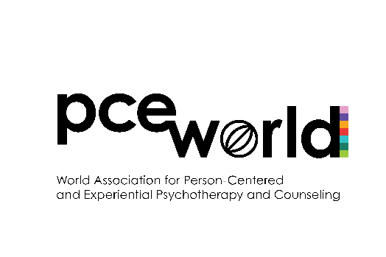
PCE World General
Research Grant Cover Page

Working Project Title
Name of Principal Investigator
Name(s) of Co-principal Investigator(s) (if applicable)
Affiliation
Work Position
Address
Telephone (inc. country code)
E-mail Address
Proposed Study Start Date:
Proposed Study End Date:

PCE World General Research Grant
Example of Proposed Budget

Item | Description | Cost | Documentation Provided
Travel (for data collection) |  |  | Yes / No / N/A
Equipment |  |  | Yes / No / N/A
Supplies |  |  | Yes / No / N/A
Consultation fees |  |  | Yes / No / N/A
Printing |  |  | Yes / No / N/A
Software |  |  | Yes / No / N/A
Participant incentives |  |  | Yes / No / N/A
Other |  |  | Yes / No / N/A
 |  | Total Cost:

Note: Please remember to submit documentation verifying each item and cost listed in the budget table (e.g., screenshot of/link to conference details and registration fee; software name and price).

Evidence of Ethical Considerations

If you are an independent researcher and your research project has not undergone review by an ethics board/committee, please complete the following:

Below we list five research practice considerations based on the World Health Organization’s (WHO) ethical guidelines for research involving human subjects. Please describe, in 1000 words or less, how you have accounted for these ethical practice considerations in the project for which you are seeking funding.

**Note: In the absence of internationally agreed research ethics guidelines, the Grants Committee has chosen to use WHO’s guidelines with the understanding that they are limited. The five considerations below serve as a general guide to aid in our evaluation process.

WHO-based Research Practice Considerations

1. Informed Consent
Researchers must ensure that participants fully understand the study’s purpose, procedures, risks, and benefits. Assessing participants’ capacity to consent is especially important, and consent processes should be adapted to accommodate cognitive, emotional, and/or other impairments.
2. Protection of Vulnerable Populations
Individuals with physical and mental health conditions, as well as children and pregnant individuals, may be more vulnerable for a variety of reasons. Extra safeguards (such as legal guardians, independent advocates, or ethics oversight) should be in place to protect their rights and well-being.
3. Client/Participant Safety
Research must be designed to avoid causing psychological harm. Protocols should include clear procedures for identifying and responding to distress, suicidal thoughts, or other mental health crises that may arise during participation.
4. Confidentiality and Data Protection
Sensitive participant information must be kept strictly confidential. This includes using secure data storage, anonymization techniques, and ensuring that only authorized personnel have access to identifying information.
5. Cultural Considerations
Researchers must respect and adapt to the beliefs, values, languages, and social norms of the participants they are working with. Researchers should ensure that the study design, consent process, and interventions are culturally appropriate and meaningful.

Application Checklist

*Place a checkmark next to the items you have completed/included in your application.

Cover Page
Narrative Proposal
Research topic/context
Main aim of the study
Short literature review
Proposed methodology
Hypothesis/research question
Anticipated results
Potential impact on the PCE field
References in APA
**Is the project feasible in scope?
**If Grant will be used for a part of a larger project, is a clear output related to the Grant specified?
Budget Sheet & Documentation
Evidence of Research Ethics Considerations
(a) Acceptance email by ethics board/committee or documentation that study is under review
OR
(b) If an independent researcher, a brief explanation of how research ethics were considered according to provided criteria
Most Current CV
Application Checklist

App
A

