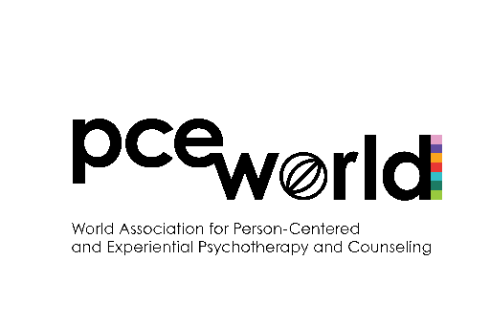
PCE World Translation
Grant Application

- Purpose and aims
- PCE World Translation Grant is a form of financial assistance provided by the World Association to Person-Centered and Experiential (PCE) researchers and practitioners who seek an opportunity to translate their writing into English in order to publish them in the PCEP Journal.
- The main purpose of the Grant is to engage the diverse population of PCE colleagues in publishing activities and to increase the diversity of PCE worldwide by making literature available regardless of the original language.
- The Grant is aimed at raising interest in and supporting the dissemination of research in the PCE approach among PCE colleagues worldwide regardless of their first language;
- It is not guaranteed that the Grant will cover 100% of the translation expenses.
- Eligibility
- Applicants must be individual members of PCE World with an active membership status for the current year.
- Applicants must not be a PCE World Board member, PCE World Scientific Committee member, PCE World chapters’ Chair or Board member, or PCEP Editor.
- There are no restrictions on applicant’s gender, age, nationality, PCE ‘tribe’ or any other basis except for those listed in 2.1-2.2 above.
- Application and selection procedure
- The PCE World Board will announce a Call for applications at least 2 months before the deadline.
- Along with the application Cover Page (see below), applicants will submit the following:
  - A document that contains the title, keywords and an abstract of their paper, up to 400 words, in English.
  - An estimated cost for the translation of the work. Provide as much detail as possible (See example budget sheet below).
  - Most current CV.
- If the proposed paper has been published elsewhere, it is the responsibility of the applicant to get all necessary permissions prior to the application submission.
- The Grants Committee (in consultation with the PCE World Board) will develop the procedure for the evaluation of applications that meet the following criteria: reflects current and emerging debates in the PCE field and originality of the proposed paper.
- The full Grants Committee must vote on the submitted applications. Depending on the number and quality of the applications, a decision to award partial Grants (1/2; 1/3) or not to award any Grants at all in the current year may be taken. The latter should be approved by the PCE World Board.
- After the Grants Committee chooses an applicant(s), it informs the PCE World Board, which will make a formal announcement and arrange for the transfer of money.
- Successful applicant(s) will receive the full amount they were granted in one payment.
- Completion procedure
- Within 10 months from the date when the Grant was awarded, recipients should submit the translated paper to the PCEP Journal.
- PCEP Journal will undertake the usual peer review process of the translated paper, and may ask for further amendments to be made.
- In the case where the translated paper is not accepted for publication by PCEP, recipients will not be required to pay back the grant and may pursue publication in another journal.

**Please email all required materials (see 3.2.1-3 above) to grants@pce-world.org
PCE World Translation
Grant Cover Page

Working Title of Paper for Translation
Last Name
First Name
Affiliation
Work Position
Address
Telephone (inc. country code)
E-mail Address

PCE World Translation Grant
Example Budget Sheet

Item | Rate | Quantity | Cost
Document Length | ______ | XXXX words
Translation Fee | €XX/word | XXXX words
Subject-Matter Expertise | Additional XX%
Proofreading/Edit | €XX/word | XXXX words
Formatting/Layout | flat fee
 |  | Total Cost:

