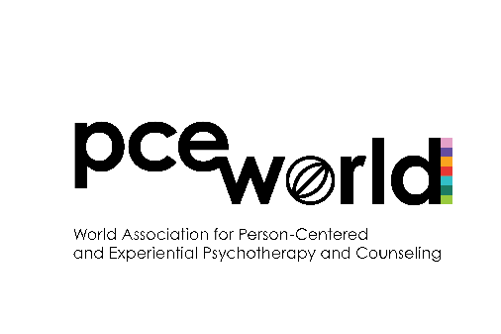
PCE World Student
Research Grant Application

- Purpose and aims
  - PCE World Student Research Grant is a form of financial assistance provided by the World Association to students whose research projects are aimed at the investigation of the Person-Centered and Experiential (PCE) approach.
  - The main purpose of the Grant is to stimulate and support students’ research activities related to the PCE field.
- Eligibility
  - Applicants must be a student at the time they apply and should maintain this student status for at least 1 academic year after the date the Grant is granted (for example: an applicant should be at the end of year 3 of a 4-year degree, or at the beginning of year 2 of a 2-year degree).
  - For the purpose of this Grant, a student is defined as a person enrolled in a degree granting program (e.g., Bachelor, Master, Specialist, Doctor, Candidate etc.) at an accredited institution of Higher Education.
  - Applicants must be individual members of PCE World with an active membership status for the current year.
  - Applicants must not be a PCE World Board member, PCE World Scientific Committee member, PCE World chapter Chair or Board member, PCEP Editor, or member of the Grants Committee.
  - There are no restrictions on applicants’ gender, age, nationality, PCE ‘tribe’ or any other basis except for those listed in 2.1-2.4 above.
- Application and selection procedure
  - The PCE World Board will announce a Call for applications at least 2 months before the deadline.
  - Applicants will complete and electronically submit all required forms (see #4 below) to the Grants Committee.
  - The Grants Committee (in consultation with the PCE World Board) will evaluate the applications based on the following evaluation criteria:
    - Significance of the research topic:
      - Clear topic context, main aim of the study, with theoretical and practical significance to the PCE field.
    - Quality of the proposed methodology:
      - Clarity of the conceptual/theoretical framework, research design, and overall methodology.
    - Feasibility of the study:
      - Feasible in scope.
      - If part of a larger project, specifies a clear output relating to the grant.
  - The full Grants Committee will vote on the submitted applications. Depending on the number and quality of the applications (assessed using the above criteria), a decision may be taken to offer partial Grants (e.g., 1/2; 1/3 of the allocated amount) or not to offer any Grant. The latter decision should be approved by the PCE World Board.
  - After the Grants Committee selects an application, the PCE World Board will be informed. The PCE World Board will then make a formal announcement and arrange for the transfer of money.
  - Successful applicant(s) will receive the full amount they were granted in one payment.
- Submission forms: All materials should be submitted together.
  - Cover Page: (see below)
  - Narrative Proposal: A 4-5 page summary proposal (1,200 – 1,500 words) that includes the research topic, main aim of the study, short literature review, proposed methodology, hypothesis/research question, and potential impact on the PCE field. **If you plan to use the Grant money for a part of a larger project, please describe a clear and specific output that will be produced using the Grant money. Please include references list in APA format, although references are not considered as part of the total word count.
  - Budget: A proposed budget documenting how you will spend the Grant money (see below).
  - Research Ethics Approval Forms: Documentation of approval/acceptance of your research project by a research ethics board/committee at your institution of higher education. If pending approval, please submit documentation that your research project is under review.
  - Most Current CV: Most current copy of your CV should be included with the packet.
  - Application Checklist: Complete the checklist below to make sure you have completed and included all required materials for this application.
- Completion procedure
  - At the end of the research project, Grant recipients should send the outcomes of their study to the PCE World Board (e.g., dissertation, thesis, paper). If a recipient decides to publish the results of the research, the PCE World Student Research Grant should be explicitly acknowledged in the paper.
  - PCEP Journal may decide to offer recipients the opportunity to submit the results of the study as an invited paper. The submission would go through the usual peer review process.
**Please complete all submission forms and email them to grants@pce-world.org
PCE World Student
Research Grant Cover Page

Working Project Title
Name of Principal Investigator (student)
Name of Principal Investigator’s Advisor
Institution of Higher Education
Name of Course Registered on
Total Duration of Course
Current Stage of Course (e.g., year 3)
Address
Telephone (inc. country code)
E-mail Address
Proposed Study Start Date:
Proposed Study End Date:

PCE World Student Research Grant
Example of Proposed Budget

Item | Description | Cost
Travel (for data collection)

Equipment

Supplies

Consultation fees

Printing

Software

Participant incentives

Other

Total Cost:

Application Checklist

*Place a checkmark next to the items you have completed/included in your application.

Cover Page
Narrative Proposal
Research topic/context
Main aim of the study
Short literature review
Proposed methodology
Hypothesis/research question
Anticipated results
Potential impact on the PCE field
References in APA
**Is the project feasible in scope?
**If Grant will be used for a part of a larger project, is a clear output related to the Grant specified?
Budget Sheet
Research Ethics Approval Forms
Acceptance email or documentation that study is under review
Most Current CV
Application Checklist

App
A

